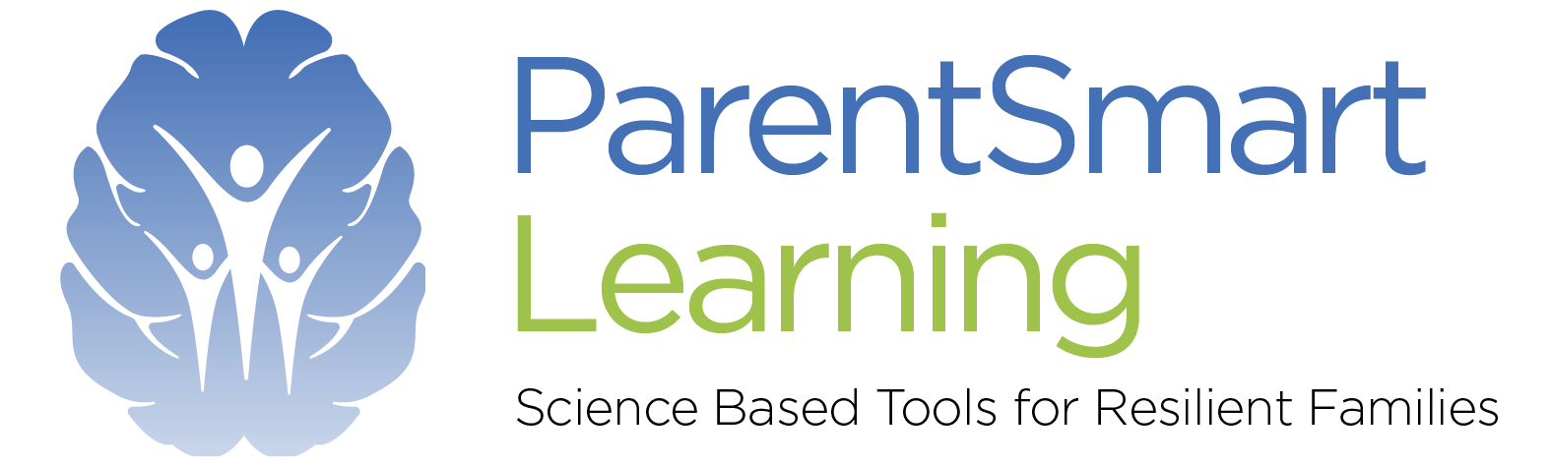
Booking Form
Please return this completed booking form to info@parentsmartlearning.com

MONDAY  LUNCHTIMES | MONDAY  EVENINGS | FRIDAY  MORNINGS
6^{th,} 13th 20th & 27th March | 6^{th,} 13^{th,} 20th & 27th March | 10th 17th 24th 31st  March
17th & 24th April and 1st and 8th May | 17th & 24th April and 1st and 8th May 2023 | 21st & 28th April and 5th & 13th May

Participant/s:

Names/Age of child/ren:

Address:

Email:

Mobile:

Fee: £85 -per person /£125- per couple / Private group of up to 10 people -£495
Course Name: Confused to Confident: A 4-week Online Course for Parents
Course venue: Online
Dates:

Payment is required to secure a place
Bank Account Details: PARENT SMART LEARNING CIC
Sort code: 82-11-07
Account number: 40197809

